Scoring at BOS 2022

# Overview

All pilots are required to email in their IGC files to Steve Penfold at [ripstra@msn.com](mailto:ripstra@msn.com) who is running the scoring this year. The easiest way to do this is to use **Tracker** (on Android) or **FlySkyHy** (on Apple).

*If your phone does not have a barometer then depending on proximity of airspace you may sometimes need to retrieve the igc tracklog from your altimeter instead and email to the same address. Please be familiar with how to do this / find somebody who does or can.*

**Tracker** can be downloaded for free from [https://mycloudbase.com/tracker/download.htm.](https://mycloudbase.com/tracker/download.htm) It is really important that you read and follow the instructions at <https://mycloudbase.com/tracker/readme.htm>, and then test to ensure your Android phone does not kill Tracker prematurely for “battery saving”. My recommendation is to CONFIGURE it, START it, and then after 10 minutes put into flight mode (and turn off WiFi). Wait for 30 minutes and then take out of flight mode for a further 10 minutes before pressing STOP.

As well as saving an igc file, Tracker can send text messages and / or a tracklog to <https://www.livetrack24.com/> once registered for a free account.

**FlySkyHy** can be installed from <https://apps.apple.com/us/app/flyskyhy/id516879039>. It is for Apple so you will need to pay for this. FlySkyHy can also send to livetrack24, but not text messages.

**Emailing tracklogs from Tracker** Before the competition on the CONFIGURE screen:

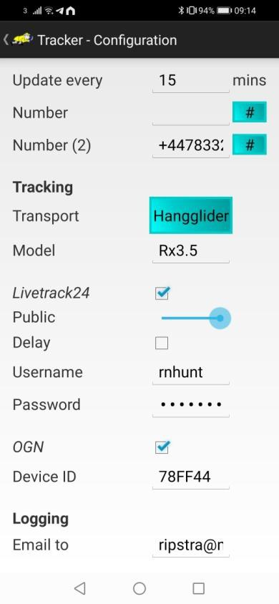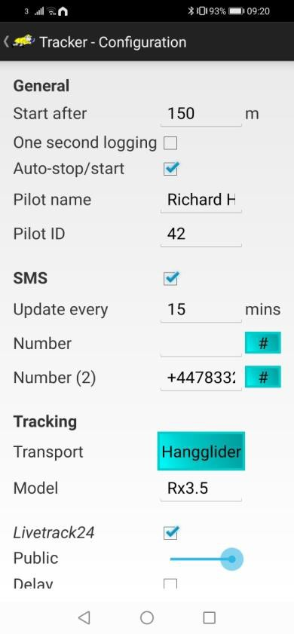

* Enter Steve’s email address of [ripstra@msn.com](mailto:ripstra@msn.com) as “Email to”
* Enter your BOS Pilot ID

After the flight:

1. Click on the three dots in the top right of the app
2. Select “Email”
3. Select your tracklog (the date is in the IGC name)
4. Select your email program
5. If you have not pre-configured the email address change this, check flight details, then send

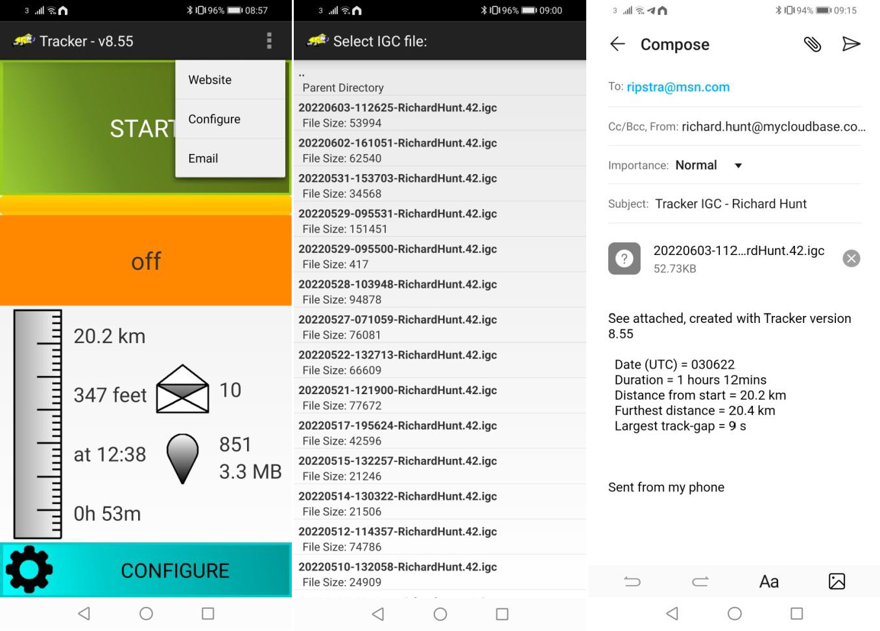

Some Android 11 and Android 12 phones have new security restrictions on the email functionality. If you are unable to email your file, or have any other issues, please contact myself at [richard.hunt@mycloudbase.co.uk](mailto:richard.hunt@mycloudbase.co.uk) or 07766 060509 / Telegram / WhatsApp / Messenger for advice.

# Emailing tracklogs from FlySkyHy

I have no information on this but I am assured it is straightforward.

R. Hunt 6/6/22